CONTROL STRATEGY OF SWITCHING REGULATORS FOR FUEL-CELL POWER APPLICATIONS
ABSTRACT
It is often assumed that the input voltage source of a switch-mode power supply is constant or shows negligible small variations. However, the last assumption is no longer valid when a fuel-cell stack is used as input source. A fuel-cell stack is characterised by low and unregulated DC output voltage, in addition, this voltage decreases in a non-linear fashion when the demanded current increases; henceforth, a suitable controller is required to cope the aforementioned issues. In this study, an average current-mode controller is designed using a combined model for a fuel-cell stack and a boost converter; moreover, a selection procedure for the controller gains ensuring system stability and output voltage regulation is developed. The proposed energy system uses a fuel-cell power module (polymer electrolyte membrane fuel cells) and a boost converter delivering a power of 900 W. Experimental results confirm the proposed controller performance for output voltage regulation via closed-loop gain measurements and step load changes. In addition, a comparison between open- and closed-loop measurements is made, where the controller robustness is tested for large load variations and fuel-cell stack output voltage changes as well.

BLOCK DIAGRAM FOR PROPOSED SYSTEM
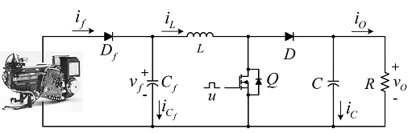
Fig. 1. Fuel-cell stack/boost converter system
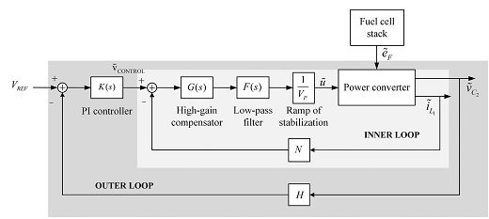
Fig. 2 Average CMC scheme for a switching regulator
DESIGNG SOFTWARE AND TOOLS:
MAT LAB /SIMULATION Software and simu power systems tools are used. Mainly control system tools, power electronics and electrical elements tools are used.

